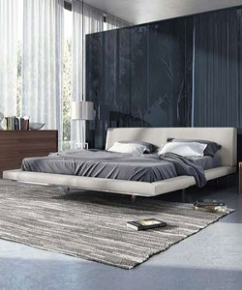

Coaster Comfortable Bed

$292.15

Availability: In stock

Description

The Perfect for a bedroom that’s classic and functional, this is the ideal starter piece for your home. Bedroom Collection that will look stunning in your newly built or renovated home. Modern white flat bed with wood legs to ensure stability and support.